Scenario Cards
Directions: Cut out the scenario cards and come up with solutions or responses.

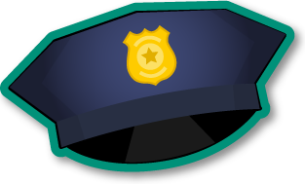  Scenario #1  As soon as you see the officer turn on their lights, or hear the blaring of his siren, what do you do? | Scenario #2  Where is the best place to pull over?
Scenario #3  You just pulled over, stopped your vehicle, now what should happen? | Scenario #4  You have on glasses that are prescription. You are smoking a cigarette. Your music is up full blast. Your driver license is in your back pocket. What should you do?
Scenario #5  You know that your brother was pulled over last year and arrested for talking back to the officer. You are really made about it and are holding a grudge. What can you do to calm down? | Scenario #6  The officer is approaching your vehicle. What should you do?
Scenario #7  The officer is looking at you. How do you react? | Scenario #8  What should you say to the officer?
Scenario #9  You have a gun under your seat. What should you do? | Scenario #10  You feel the officer is harassing you. What should you do?
Scenario #11  What type of documentation do you need to show the officer? You do not have it. What should you do? | Create Your Own Scenario  Describe what is happening. What should you do?

