Scavenger Hunt
Directions: Search and find pictures of items that you could use as equipment when you are stuck at home or if you are working a lot and are out on the road.

Rules:
- You can only look in and around your house for items.
- The workouts can be done using minimal space
- No item can cost any or little money.
- All workouts must be completed in a short amount of time.

Example:
 | CAN be done using minimal space | COSTS little or  no money | CAN be completed in a short amount  of time
Insert your example:  Bungee cord | YES or NO | already paid | YES or NO
Example Exercise:
An example is a 3-foot-long bungee cord with the end hooks clipped off for safety, or a piece of rubber tubing. Tie a knot at each end for a better grip. Just like that, you now have an exercise band.

Include Photo:
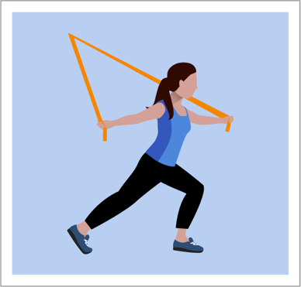

 | CAN be done using minimal space | COSTS little or  no money | CAN be completed in a short amount  of time
Insert your example: | YES or NO |  | YES or NO
Example Exercise:

Include Photo:

Insert your example: | YES or NO |  | YES or NO
Example Exercise:

Include Photo:

Insert your example: | YES or NO |  | YES or NO
Example Exercise:

Include Photo:

Insert your example: | YES or NO |  | YES or NO
Example Exercise:

Include Photo:

Insert your example: | YES or NO |  | YES or NO
Example Exercise:

Include Photo:

Insert your example: | YES or NO |  | YES or NO
Example Exercise:

Include Photo:

Insert your example: | YES or NO |  | YES or NO
Example Exercise:

Include Photo:

